10 Design Tips for Missionaries
Guaranteed to Improve Your Communications

It’s important to understand basic design principals, whether or not you see yourself as a creative. The ultimate function of design is to communicate a message. Every good missionary understands the necessity of communicating their message in the right language and with cultural intelligence—thoughtful design should be a part of that equation.

We live in a visual world. The bar for communications has been raised and expectations are higher than ever before. Good design creates a connection with your partners, whereas and bad design can sever that connection.

But before you get nervous about fonts and colors, remember this one point: Readability is the most important part of design.

If you get that, you have figured out the most important part.

Here are ten more tips to help improve readability and make your design look more professional:

- Consider Hierarchy.
Designate titles, subtitles, body text, and captions—give each a unique style and size. And then be consistent.

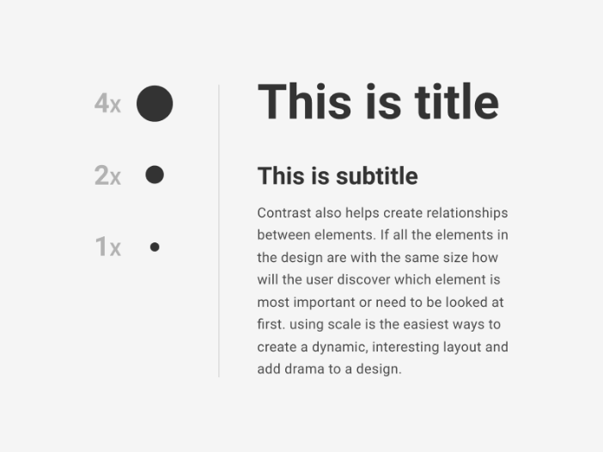

- Consistency is key.
Once you designate a font, size, and color for your hierarchy, be consistent. That will help the reader more quickly prioritize and organize the information you are giving them.

- Fonts
Stick to using 2 fonts, but choose a font with a large family. That means you should look for something that includes various weights (bold, medium, light, etc.), and italics, as well as narrow options.

For websites, blog, and email, 16pt font is an ideal minimum. You can go larger if your readers tend to be 40 and over.

- Line Height
Make your line height 120-150% of the text height. If you are using a 10pt font, use a 1.2 – 1.5 line spacing.

- Contrast
Black text on a white background is almost always the easiest to read. White text on a colored background is difficult. Use this only for very small amounts of text. Consider using contrasts in scale to draw attention to your most important information.

- Make your text as scannable as possible.
Format in a way that allows the reader to find your most important content quickly and easily. Then entice them to read more from there. Use bullet points, number lists, and “chunking”—breaking text into smaller, more digestible sections.
Try using thin lines or a box around text to accomplish this.

- Use white space generously.
Don’t completely fill the page—give readers a large margin around the text. White space helps guide the eye from place to place and give them a brief place to rest.

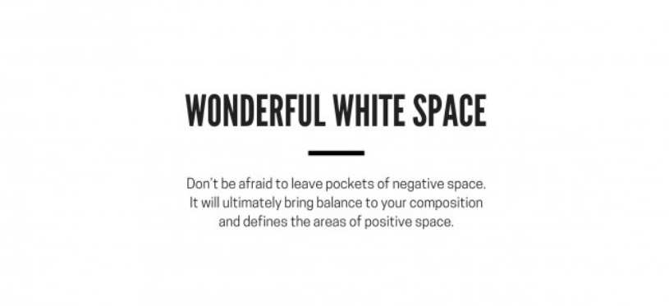

- Emphasize your most important content.
Use bolded or underlined text, or a different color text. Remember to stylize weblinks to draw subtle attention to them.

- Don’t go too long: Ideal line length is 50-75 characters
If you make lines too long, people have a hard time staying focused. If they are too short, people start skipping lines and will miss information.

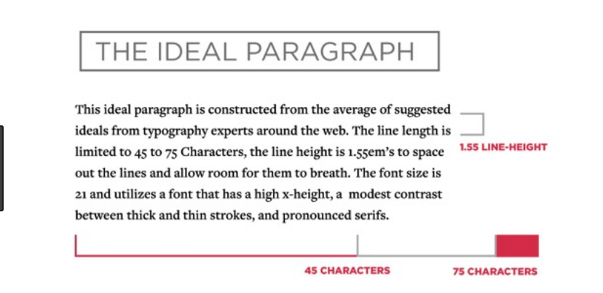

- Adding graphics.
Never let your images disrupt your text—give images plenty of white space between them and text, with clean edges. Think of all your information as living with in a grid and then align images to that grid.

